Palm Beach Community College

and

SpaceTec Outreach Project

“Lunch and Launch”

May 3, 2003
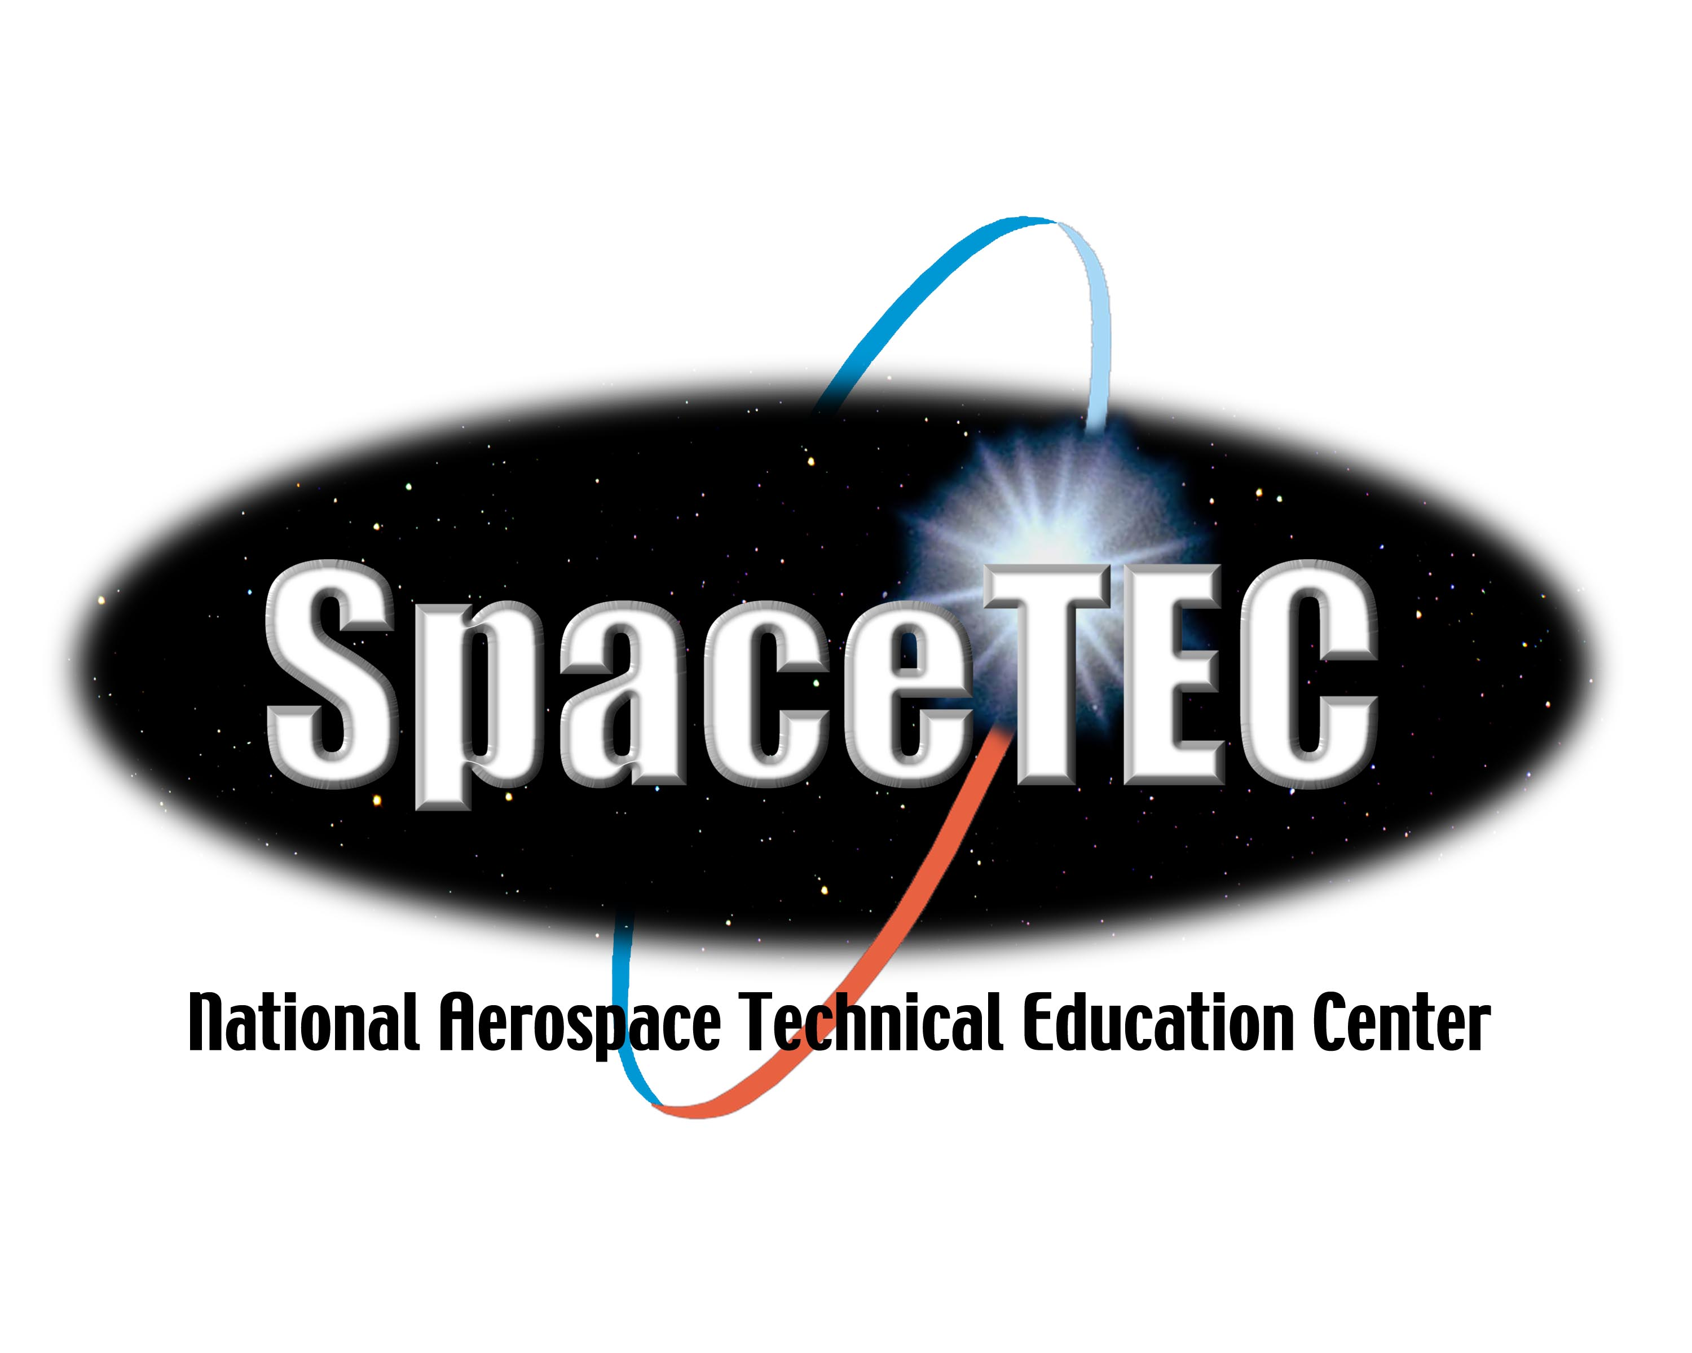



AGENDA
LUNCH & LAUNCH
MAY 3, 2003
SOUTH FLORIDA SCIENCE MUSEUM
WEST PALM BEACH

8:00 – 8:30 A.M. Sign-up, Coffee and Donuts

8:30 – 8:40 Welcome – Dr. Thomas Steffen, SpaceTEC Co-PI

8:40 – 10:15 “Evolution of Aerospace & Introduction to Aerospace Workplace” (Motorola Theatre)
By Peri Baker-Horner
Brevard Community College

10:15 – 10:30 Break

10:30 – 12:00 Continue “Evolution and Introduction” from 8:40 AM

12:00 – 1:00 Lunch and Rocket Making (Located in Museum Rooms)

1:00 – 1:30 “How Rockets Work.” What to bring back to your classroom
(In Motorola Theatre)
Dr. Jon Saken and John Berryman
Palm Beach Community College

1:30 – 2:00 Outside Rocket Launch

2:00 – 2:30 Prize for rocket launch, door prizes (everybody wins)
Distribution of SpaceTEC materials (Motorola Theatre)

2:30 - End of Lunch and Launch Put rocket launchers in your car. Tour museum on your own, if you wish.

SUMMARY

The PBCC Outreach Project was held on Saturday, May 3, at the South Florida Science Museum in West Palm Beach, Florida. The venue was a 50-seat theatre in the museum. Twenty-eight Science, Math, Engineering and Technology teachers from the Palm Beach County School System signed up for the
8:30 a.m. til 2:30 p.m. activity.

At 8.30 AM, after coffee and donuts, Dr. Tom Steffen provided background about SpaceTec, the NSF, and the Aerospace Technician Program. Then, Peri Baker-Horner, an instructor at Brevard Community College, gave a shortened version of the “Introduction to the Aerospace Workplace” and “Evolution of the Aerospace Industry.” The slide show lasted until 12:00 p.m., with a coffee break at 10:00 a.m.

At 12:00, a catered lunch was served in the lunchroom of the museum. During lunch, paper, scissors, tape and templates were passed out and each of the participants was given instructions on how to make his/her own rocket.

At 1:00 p.m., the group reassembled in the theatre for a funny presentation by two PBCC physicists explaining how rockets work. The presentation was given with the idea that each teacher could bring the demonstration back to his or her classrooms.

At 1:30 on a sunny warm day, at the entrance to the museum, the teachers were issued their own PVC rocket launchers. With the aid of two electric compressors, each teacher launched a rocket on his/her own rocket launcher.

At 2:00, the teachers loaded their rocket launchers into their cars and returned to the theatre for the door prize portion of the program.

The last part of the program consisted of door prizes and evaluations of the program. The prize for the rocket that went the farthest was one of the air compressors. Each of the participants won small door prizes, as well as a NASA Educator’s Package, a gift bag, a VHS tape of NASA Videos, a CD Rom of the Presentation, a CD Rom of various NASA slides, a $75 stipend, and a bicycle pump.

At 2:30 p.m., the evaluations were collected and the participants left for home. A quick review of the evaluation showed a very happy, well-informed and pleased group of teachers who planned to use the information in their classrooms.

DETAILS

The School Board of Palm Beach County has a Science Technical Coordinator for the District. It is his job to provide information to teachers about upcoming outreach programs. In February, he was contacted, agreed to provide in-service points for the teachers who signed up and agreed to publicize it in the appropriate media. No additional publicity was undertaken. It was agreed that the program would be limited to 30 teachers.

The museum was contacted and the theatre and the backroom were rented for the day. It was agreed that the museum would provide coffee and donuts before the 8:30 a.m. start, and would provide additional personnel, as the museum would not formally open until 12:00 that day. The museum also contracted for the catered lunch.

Dr. Tom Steffen had his “Introduction to Engineering” class assembly 35 rocket launchers in a central courtyard at Palm Beach Community College three weeks before the scheduled event. Dr. Steffen purchased all the launches pieces from Lowes and Home Depot. In his garage at home, he did the critical threading of the pressure gauge and the Schrader valve.

To assure strength, the valve and the gauge were threaded and glued into place.

To assure that construction was satisfactory, the “Introduction to Engineering” class tested two of the rocket launchers. The assembly event also received wide viewing as most of the rockets launched landed in the parking lot or a main entrance walkway during class changes.

The media coverage of the launch was coordinated by the PBCC Marketing Department. Two stories in the local papers were the result.

The video of the program was done by the PBCC Media Department. Six VHS tapes were produced.

Several days after the program, Dr Steffen received five emails as a direct result of the articles in the paper.

Phone calls and e-mails from the school board coordinator and the Director of Education for the museum also confirmed a successful program.

Lessons Learned

1. Teachers react favorably to lunch, stipends, and in-service points.

2. Coordinating a small project such as this takes more time and effort than imagined.
Major problems occurred with the College accounting department. Purchasing of supplies without purchase orders was a problem solved by use of the college credit card.

3. Teachers wanted more hands-on activities to bring back to their classrooms.

4. The slide show from 8:30-12:00 was too long, too much and some of the info was not at all of interest to the teachers, even though it was well presented.

5. A follow through or a connection must be made between the outreach program and the Aerospace Technician Program. PBCC does not have an Aerospace Program presently. When asked where students can to go join the program, the only answer was Brevard Community College.

6. The use of an assistant to help complete making the rocket launcher would be a great time saver.

7. Lunch was a great idea. The use of a local caterer made the lunch an enjoyable affair.

8. The possibility of having each teacher make his or her own rocket launcher should be explored as a possible alternative to a long slide show.

9. Dressing the teachers in Clean Room suits would also provide a useful activity for future programs.

10. The scheduling of a starting time may be critical as 40% of the teachers arrived late.

11. A still camera is necessary to capture many of the activities during the program. Dr. Steffen did not have enough time to catch all the great shots. A person will dedicated to this activity would do a better job.

12. A quick email report to all the PBCC personnel, President, Vice Presidents, Media, , etc. immediately after the program thanking everyone and providing praise to all the helpers was a good move.

13. Back up media equipment is a must. Although the museum had equipment, it was not compatible with our equipment. The PBCC Media Service provided projector, sound equipment, and computer for the program. This eliminated most of the technical glitches.

COSTS
(Costs are approximate)

1. Rental of Museum and backroom for one Saturday 450.00

2. Coffee, donuts, lunch 300.00

3. 35 Rocket Launchers @ $30.00 each 1,050.00

4. Video tape and CD reproduction 300.00

5. Stipends 28 @ $75.00 each 2,100.00

6. Hotel, speaker stipend, travel 500.00

$4,700.00

